Creating a Data Statistical Report from a CPIN System
1. Log into the CPIN system using your own credentials.
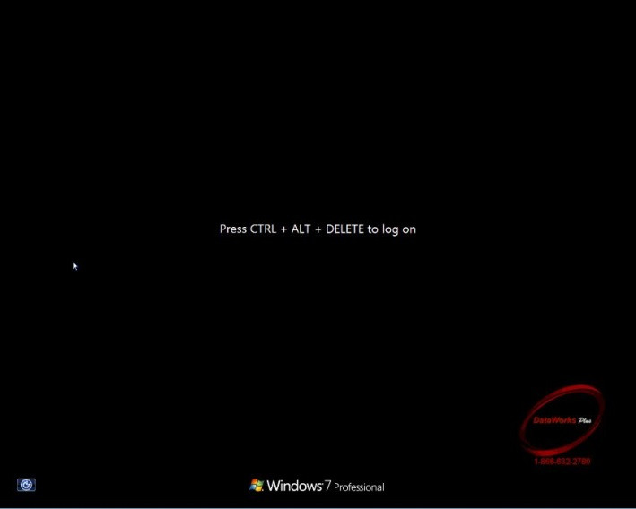

2. When system login is complete, double-click on the "Image & Data Retrieve" icon
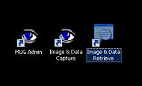

3. Once the application opens, ensure the CPIN option is selected and click OK.

4. From the Database selection on the top-left, highlight “Local CPIN Arrestee Database”
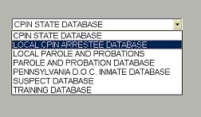

5. The “Local CPIN Arrestee Database” will appear.
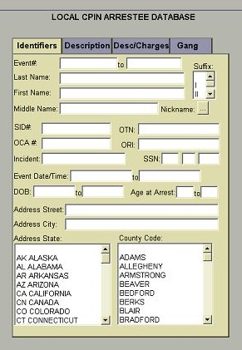

6. Enter a Date/Time (for example, 3/1/2017 to 3/31/2017) and click “Find” at the bottom.
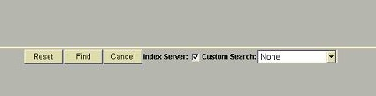
7. The results for the time period will display in a listing.
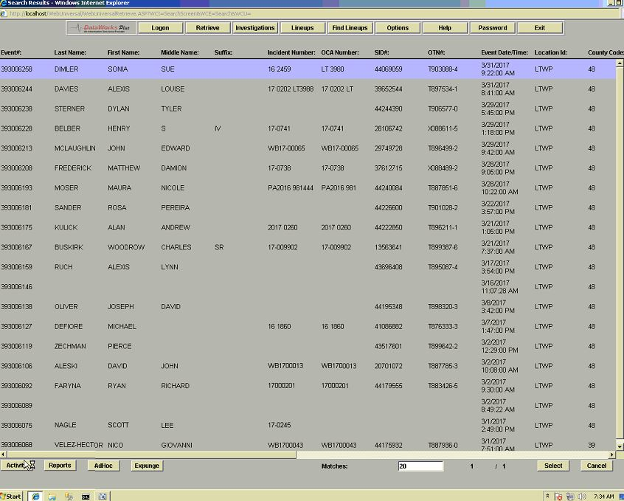

8. Clicking on the “Reports” button at the bottom of the screen will prepare a report with all of the results listed and allow report printing.
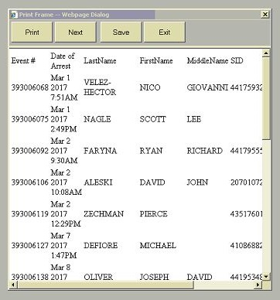
9. Clicking on the “Adhoc” button at the bottom of the screen will allow you to create customized reporting by adding requested fields only
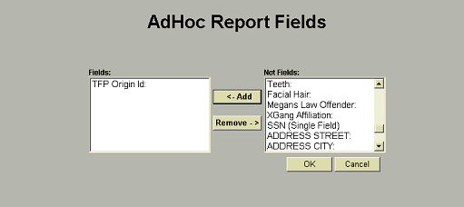

10. There should be a training manual at each site that covers this application in detail. To create a customized report, some visual aids are helpful. If using Web/CPIN, the steps are exactly the same.

